Task on Load Balancers

1: Configure Classic Load balancer.
Objective
Create a Classic Load Balancer and distribute HTTP traffic between two EC2 instances in different Availability Zones.
1. Create EC2 instances
Create 2 EC2 instances:
Instance | AZ | Subnet | Apache Port
majeed-clb-ec2-1 | us-east-1a | majeed-public-subnet | 80
majeed-clb-ec2-2 | us-east-1b | majeed-alb-subnet-2 | 80
Use:
- Amazon Linux 2023
- t3.micro
- Key pair: khan
- Auto-assign Public IP: Enable
2. Security Group
Create/use:
majeed-clb-ec2-sg
Inbound rules:
HTTP | TCP | 80 | 0.0.0.0/0
SSH | TCP | 22 | 0.0.0.0/0
SSH from 0.0.0.0/0 is okay for this temporary lab, but restrict it to your IP in a real environment.
3. Install Apache on both EC2s
sudo yum install httpd -y
sudo systemctl start httpd
sudo systemctl enable httpd
Check:
sudo systemctl status httpd
4. Create different test pages
On EC2-1:
echo "Hello from EC2-1 - Classic Load Balancer" | sudo tee /var/www/html/index.html
On EC2-2:
echo "Hello from EC2-2 - Classic Load Balancer" | sudo tee /var/www/html/index.html
Test locally:
curl localhost
5. Create Classic Load Balancer
Go to:
EC2 → Load Balancers → Create Load Balancer → Classic Load Balancer
Configuration:
Basic configuration
- Name: majeed-classic-lb
- Scheme: Internet-facing
Network mapping
- VPC: majeed-vpc
- us-east-1a → majeed-public-subnet
- us-east-1b → majeed-alb-subnet-2
Security Group
- majeed-clb-ec2-sg
Listener
- Load Balancer: HTTP : 80
- Instance: HTTP : 80
Health Check
- Protocol: HTTP
- Port: 80
- Path: /index.html
- Timeout: 2 seconds
- Interval: 5 seconds
- Unhealthy threshold: 2
- Healthy threshold: 10
Instances
- majeed-clb-ec2-1
- majeed-clb-ec2-2
Attributes
- Cross-zone load balancing: On
- Connection draining: On
- Timeout: 300 seconds
6. Verify health
After creating the CLB:
EC2 → Load Balancers → majeed-classic-lb → Target instances
Both should show:
In-service
7. Test CLB DNS
Copy the DNS name of the CLB and open:
http://<CLB-DNS-name>
Example:
http://majeed-classic-lb-963554981.us-east-1.elb.amazonaws.com
You should receive:
Hello from EC2-1 - Classic Load Balancer
or
Hello from EC2-2 - Classic Load Balancer
Refresh the page to demonstrate that the CLB can send requests to the healthy instances.
Final result
Internet
|
↓
Classic Load Balancer
majeed-classic-lb
/ \
↓ ↓
EC2-1 EC2-2
us-east-1a us-east-1b
| |
Apache Apache
:80 :80
Task 1: Configure Classic Load Balancer — COMPLETED ✅

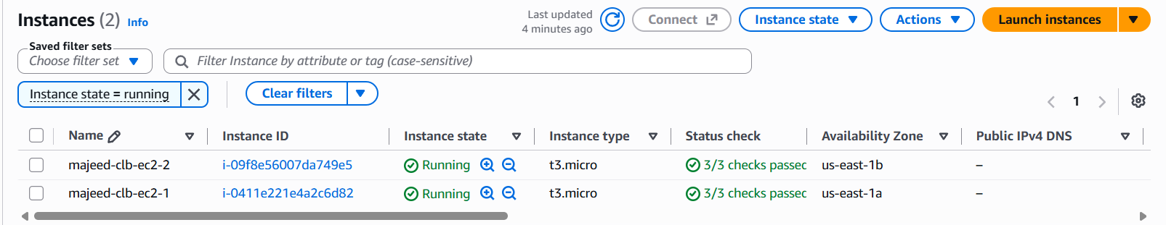
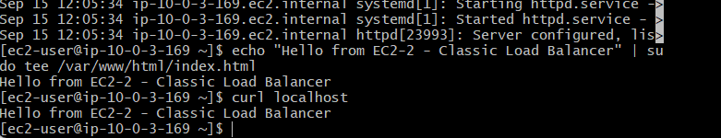
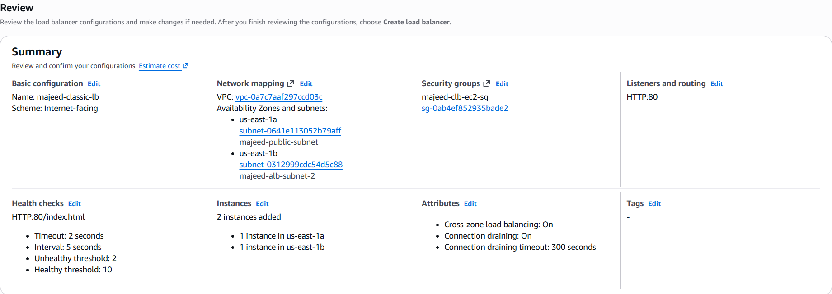
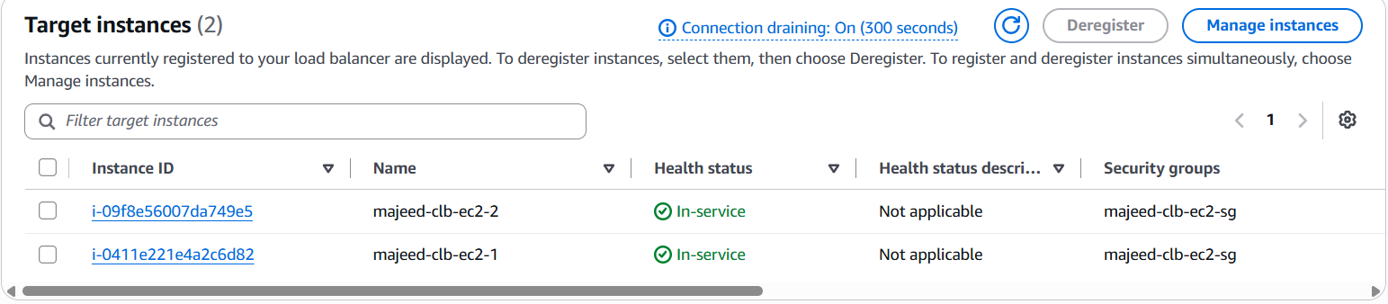
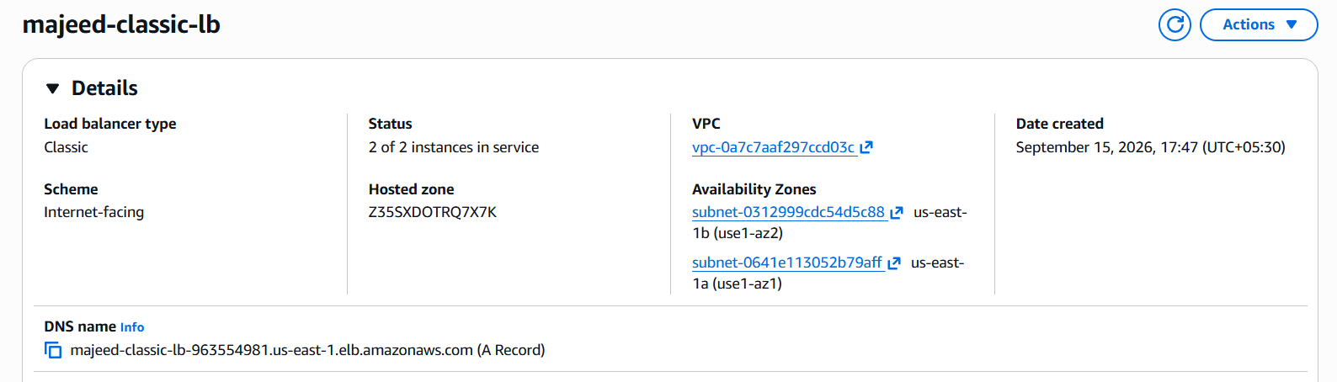
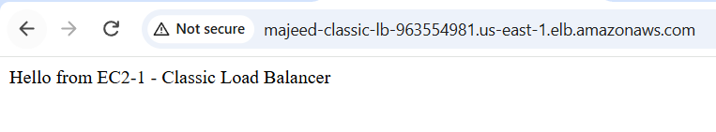
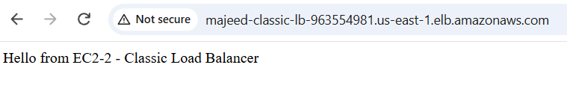

2: Configure Application Load balancer.
- Create a Target Group
  - Name: majeed-alb-tg
  - Target type: Instances
  - Protocol: HTTP
  - Port: 80
  - Health check path: /index.html
- Register both EC2 instances:
  - majeed-clb-ec2-1
  - majeed-clb-ec2-2
- Create an Application Load Balancer
  - Name: majeed-alb
  - Scheme: Internet-facing
  - IP address type: IPv4
  - VPC: majeed-vpc
- Select two subnets in different AZs:
  - majeed-public-subnet → us-east-1a
  - majeed-alb-subnet-2 → us-east-1b
- Select security group:
  - majeed-clb-ec2-sg
- Configure listener:
  - HTTP : 80
  - Forward to majeed-alb-tg
- Wait for ALB status → Active
- Check target group:
  - Both EC2 instances → Healthy
- Copy the ALB DNS name and open it in the browser.
- Verify the response:
- Hello from EC2-1 - Application Load Balancer
- Hello from EC2-2 - Application Load Balancer

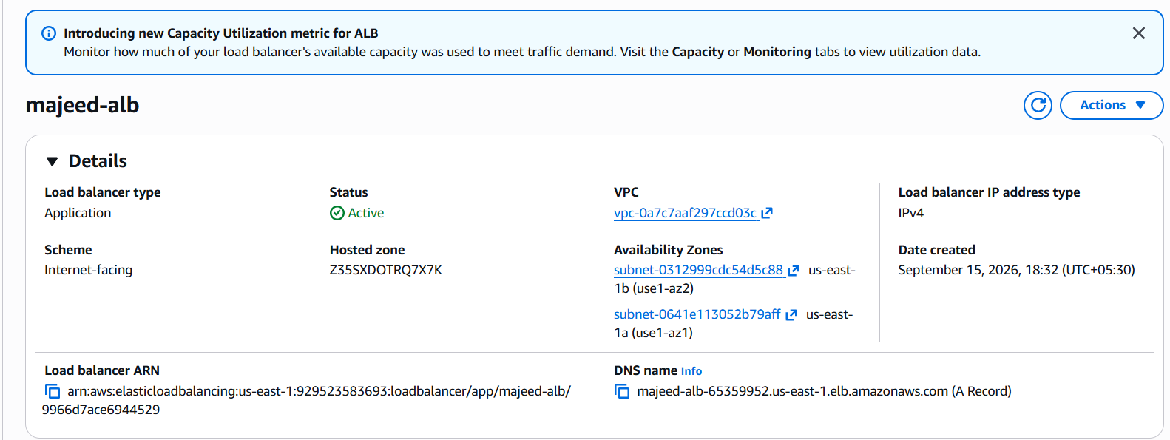
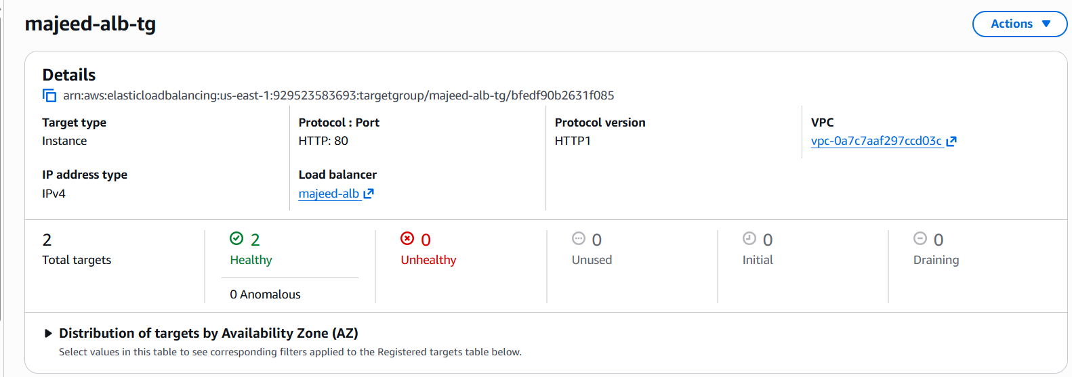
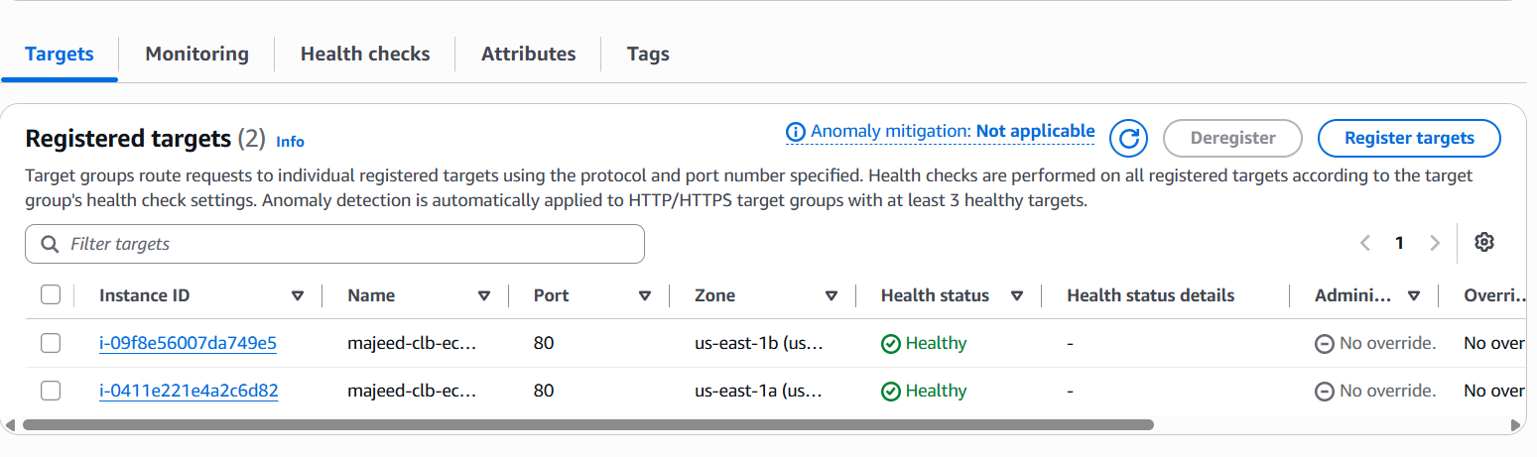
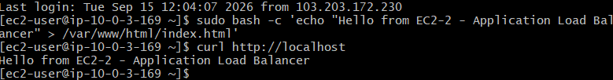
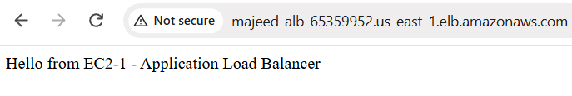
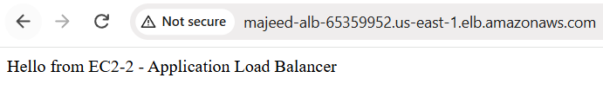
3: Configure Network Load balancer.
- Created target group majeed-nlb-tg.
- Target type: Instances.
- Protocol: TCP, Port 80.
- VPC: majeed-vpc.
- Health check: TCP, traffic port.
- Registered both EC2 instances:
  - majeed-clb-ec2-1
  - majeed-clb-ec2-2
- Started creating Network Load Balancer majeed-nlb.
- Scheme: Internet-facing.
- IP address type: IPv4.
- Selected two AZs:
  - us-east-1a → majeed-public-subnet
  - us-east-1b → majeed-alb-subnet-2
- Listener: TCP:80 → majeed-nlb-tg.
- Target group stickiness: Off.
- NLB creation failed because AWS returned:
OperationNotPermittedException — AWS account currently does not support creating load balancers.
Result: NLB configuration completed, but NLB creation is blocked by an AWS account-level restriction, not a networking configuration issue.
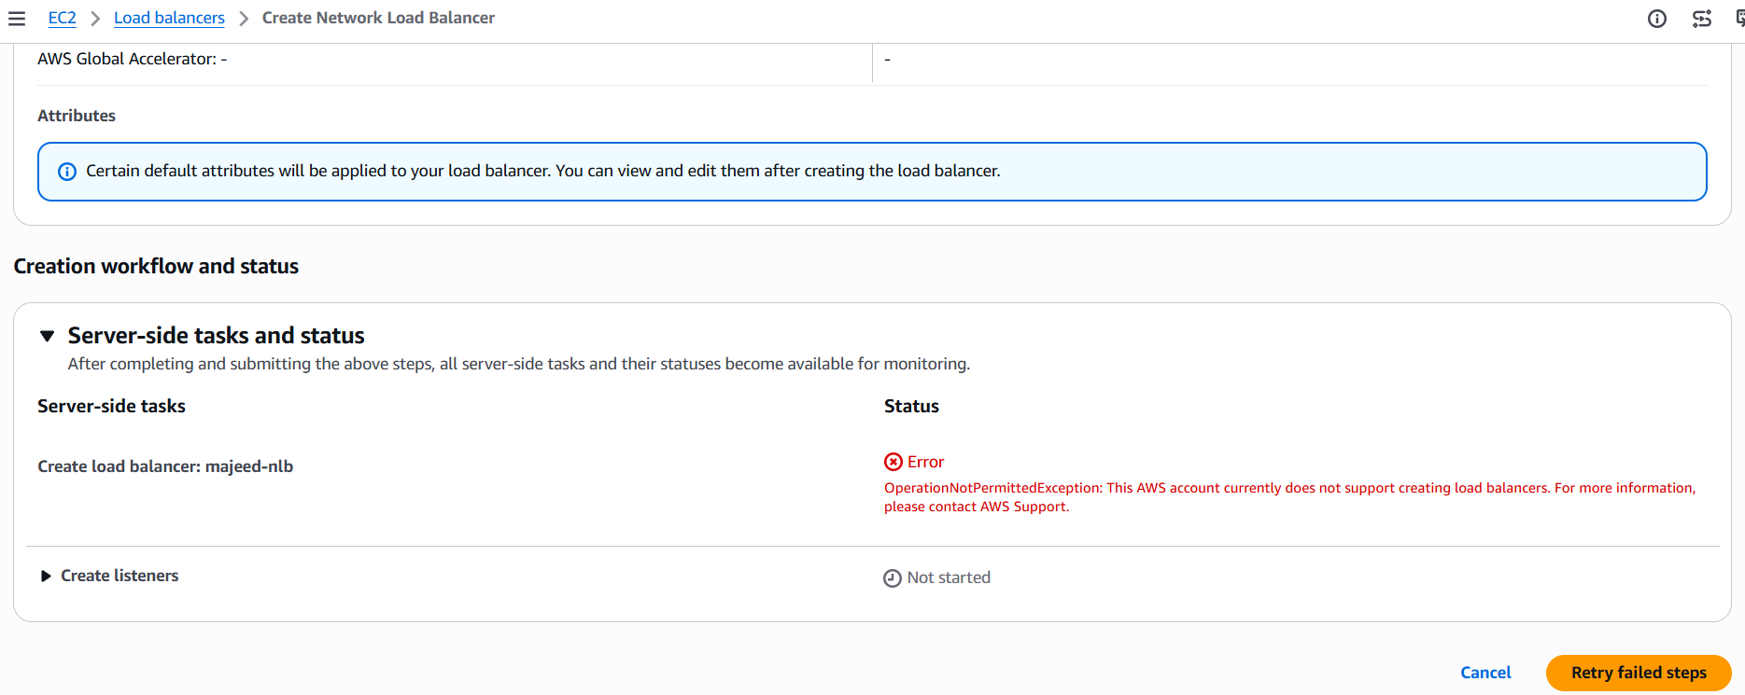
Task 3 — NLB configuration completed, but NLB creation is blocked by an AWS account-level restriction (OperationNotPermittedException).

4: Attach SSL for application load balancer.
Steps
- Open AWS Console → EC2 → Load Balancers.
- Select majeed-alb.
- Go to Listeners and rules.
- Click Add listener.
- Select:
  - Protocol: HTTPS
  - Port: 443
- Under Default action, select:
  - Forward to target groups
  - Target group: majeed-alb-tg
  - Weight: 100%
  - Stickiness: Off
- Keep the recommended Security policy.
- Under Default SSL/TLS server certificate:
  - Certificate source: From ACM
  - Select certificate: majeedkhan.in
- Keep mTLS unchecked/off.
- Tags are optional, so leave them empty.
- Click Add listener.
- Verify HTTPS:443 appears under the ALB listeners.
Short notes
Task 4: Attach SSL for Application Load Balancer
- Open majeed-alb → Listeners and rules.
- Add HTTPS:443 listener.
- Forward traffic to majeed-alb-tg.
- Select ACM certificate majeedkhan.in.
- Keep mTLS Off.
- Click Add listener.
- Verify HTTPS:443 listener and certificate are attached.
Status: Task 4 Completed ✅

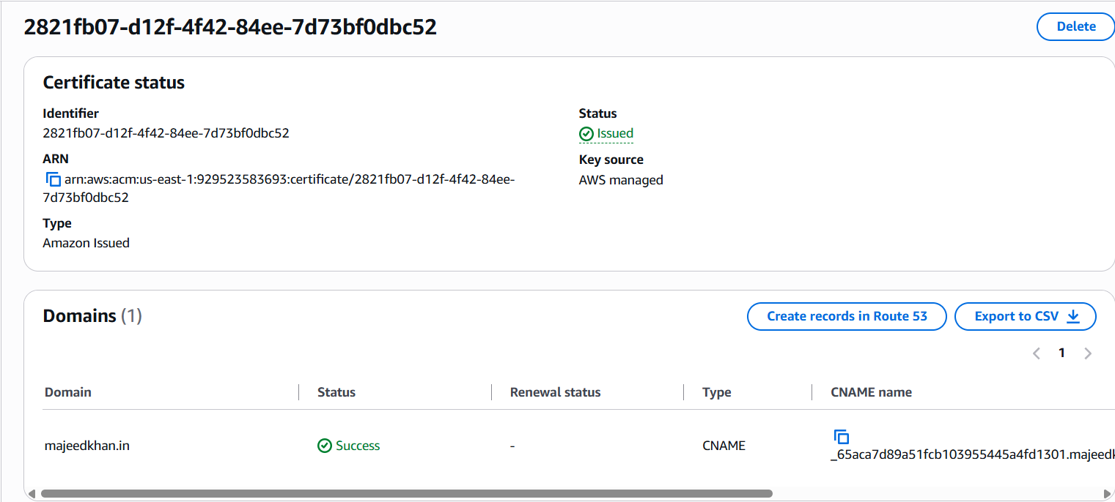
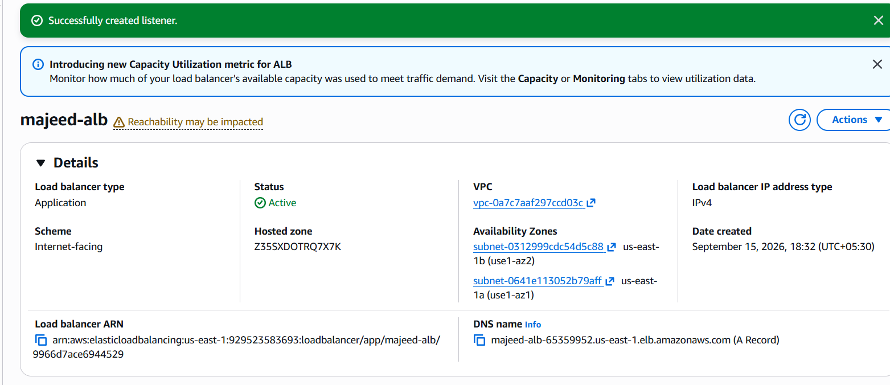
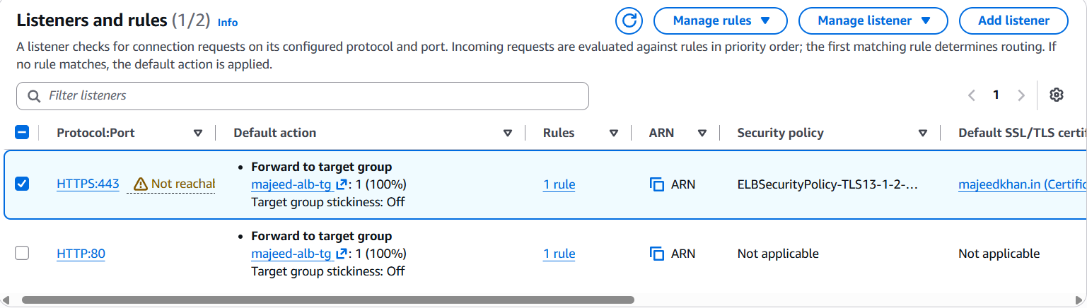

5: Map Application load balancer to R53.
Steps
- Open AWS Console → Route 53.
- Go to Hosted zones.
- Open the hosted zone majeedkhan.in.
- Click Create record.
- Configure the record:
  - Record name: Leave blank
  - Record type: A
  - Alias: ON
  - Route traffic to: Application and Classic Load Balancers
  - Region: US East (N. Virginia) / us-east-1
  - Load balancer: majeed-alb
  - Routing policy: Simple routing
  - Evaluate target health: Yes
- Click Create records.
- Verify the A record points to:
dualstack.majeed-alb-65359952.us-east-1.elb.amazonaws.com
- Test the website:
https://majeedkhan.in
- Verify the EC2 Apache page is displayed.
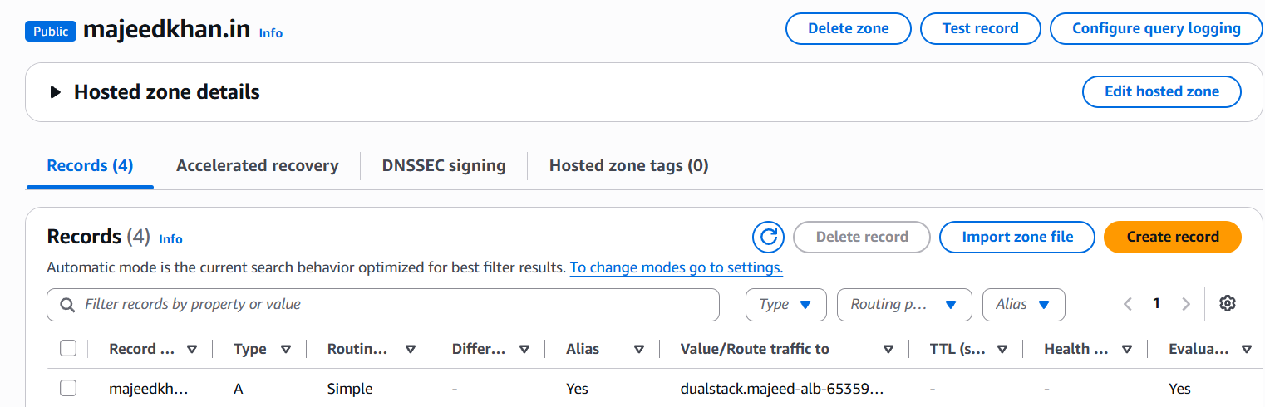

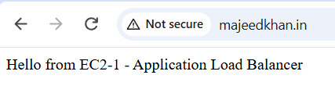
6: Push the application load balancer logs to S3.
Steps
- Open S3 → Buckets.
- Use the existing bucket:
majeed-alb-logs-2026
- Open EC2 → Load Balancers.
- Select majeed-alb.
- Go to Attributes.
- Find Access logs.
- Enable Access logs.
- Select S3 bucket:
majeed-alb-logs-2026
- Save the changes.
- Generate traffic by opening:
https://majeedkhan.in
- Open the S3 bucket and verify:
AWSLogs/929523583693/elasticloadbalancing/us-east-1/2026/09/
- Verify date folders such as 11, 12, 13, 14, 15 are present.
